**Bosch Tips**

**Automatic start - correction bookings**

**Setting up the automatic start of the Bosch website  
(Time booking in Windows autostart):**

1. Please open time.leibniz-zmt.de in the Microsoft Edge browser and click on  
“Settings and more"

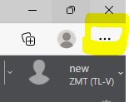

1. Select “Apps” then click on “Install this website as an app”.
2. Now you have the possibility to rename the page or app, but you don't have to. Then please click on "install“.
3. An “App installed” popup window appears.

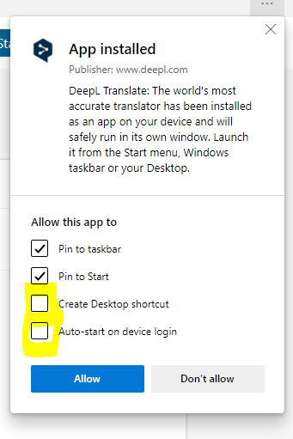

Please check "Create Desktop Shortcut" and "Auto-Start on device login".

5. Done ☺   
When you log on to the computer again, Bosch opens automatically. (Attention, the automatic opening takes a few seconds. And if you are working from home and connected via remote or VPN, Bosch will not open automatically because the computer is still logged in).

**What cannot be corrected:**Original bookings made in the dashboard via the come/go button or which were booked at the terminal (installation still pending) cannot be overwritten.

This is why original bookings appear with a lock icon:

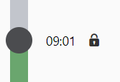

If you have corrected a time yourself, a person icon appears instead of the lock icon. You can then directly click into this time and simply change it or delete it via the trash can icon.

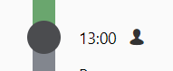

The following hints should help in most cases. 'Clock break / end of presence' instead of

**Correct own time bookings – Accidentally booked double attendance**

If e.g. at the end of the working day you have accidentally clicked 'Clock start of presence' instead of 'Clock break / end of presence' Bosch overwrites the first entry and calculates the daily target time minus or displays ‘Activity invalid’ in the correction mode.

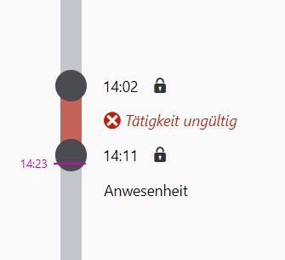

In this case you click into the text 'presence'(Anwesenheit) and change it to 'Break/absence', now the red bar changes to green and 'Presence' is displayed. Then you only have to confirm the booking (lower right corner) and you are logged out.

**Correct own time bookings - Forgotten coming/going booking:**

1. Come-booking forgotten and not yet stamped the start of attendance:

„Correct your own time bookings“ 🡪 🡪 Select "Point in time", specify start time, select type "Presence" and confirm (twice).

1. Booked in too late or start of attendance already captured:

If you have already started at 8:00 a.m. but only stamped the attendance start at 8:30 a.m., this original booking is not to be overwritten, however, you can put an attendance before the original booking:

„Correct own time bookings“ 🡪 🡪 Select "Period" and select time interval, e.g. from 8:00-8:29, with the presence type and confirm (twice).

The presence cannot be corrected from 8:00-8:30, because there must be at least one minute break between two presences.

1. Booking of going forgotten and no late end of absence captured:

3a. The day after forgetting to book: „Correct your own time bookings“ 🡪 Looks like this:

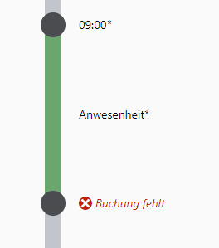

🡪 Then please click in the red text field "Booking missing"(Buchung fehlt) and enter and confirm the time of the actual closing time.

3b. On the same day: „Correct your own time bookings“🡪 🡪 select “Point in time” 🡪 insert the real time of closing and select type “break/absence” 🡪 Confirm (twice)

1. Booked out too late or end of absence already stamped:

As with 2. you cannot overwrite the original booking of e.g. 17:30. However, it is possible to insert a break or absence if the actual end of work was already at 16:20:

„Correct own time bookings“ 🡪 🡪 Select "Period" and time interval e.g. from 16:20-17:29 with the type Absence and confirm (twice).

The absence cannot be corrected from 16:20-17:30, because there must be at least one minute of presence between two absences.

**Correct own time bookings - Forgotten break booking:**

Note: Only if you have taken a break of more than 30 minutes (if you have worked more than 6 hours) or 45 minutes (if you have worked more than 9 hours), you have to correct the break times, e.g. if you have visited the cafeteria longer than planned or similar.

30 or 45 minutes are automatically deducted.

🡪„ Correct own time bookings“ 🡪 🡪 „Select "Period" and time interval e.g. from 12:00-13:00 with the type Absence and confirm (twice).

Status October 2022: This document is continuously updated.

Status 30.08.2022: This document is continuously updated.