**Guide – How to Bosch - English**



**Bosch-Time Recording System**

* 1. Training for employees (page 2)
* 2. Training for supervisors (page 15)

🡪 Employees only need to pay attention to part 1

**I. Training employees**

* 1. How to log in 2
* 2. Booking of coming and going 4
* 3. Correct your own time bookings 6
* 4. Request absences 7   
  (holidays or time compensation)
* 5. Information 8
  + 5.1 own requests 8
  + 5.2 annual calendar 9
  + 5.3 monthly journal 10
* 6. Hints 12
* 7. Advantages of Bosch 13
* To dos before getting started 13

1. How to log in?

* Link to the Bosch-Time Recording System:   
  https://time.leibniz-zmt.de/
* Your username is your personnel number.

🡪 You can find this number on your pay slip or ask for it in the personnel management. Your personnel nr. Is 7 digits long. Please delete the space between the last numbers.

🡪 Tipp: Please make a good note of this nr., e.g. a post-it on your monitor.

* The start password is „123“🡪 You will be asked to adjust the password, here our allround password is suitable.
* Please choose your language
* Attention: You´re only able to log in from the date of activation.

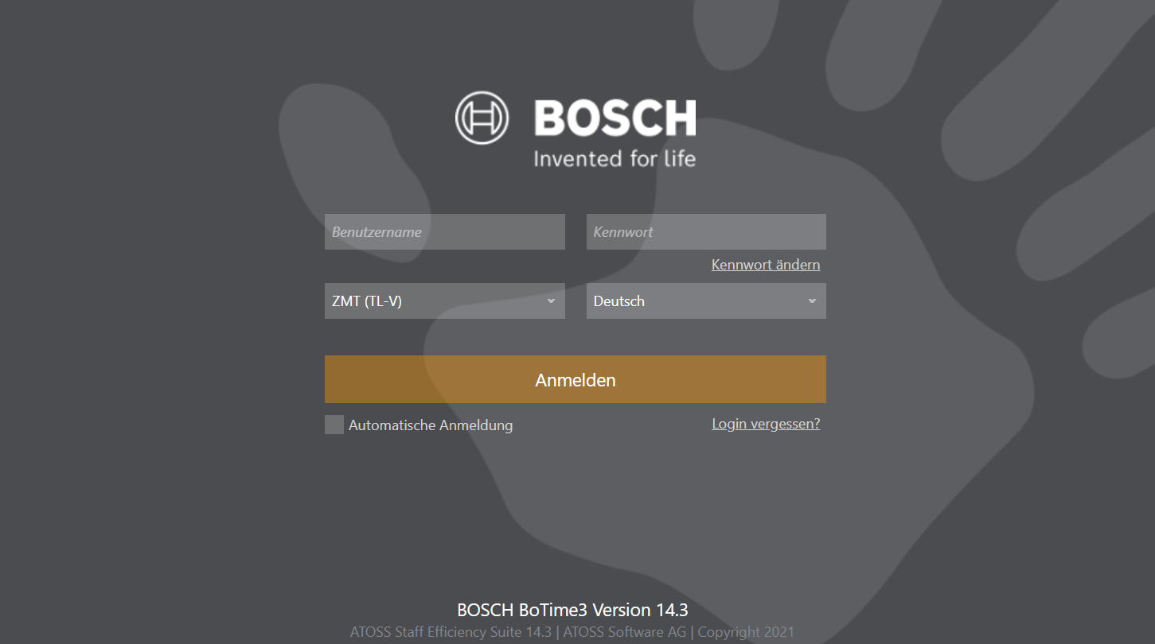

Choose English or German/Deutsch

Start password: 123

Please fill in your personnel nr. here.

Attention for supervisors: Your Dashboard might appear in the switched modus and look like this:

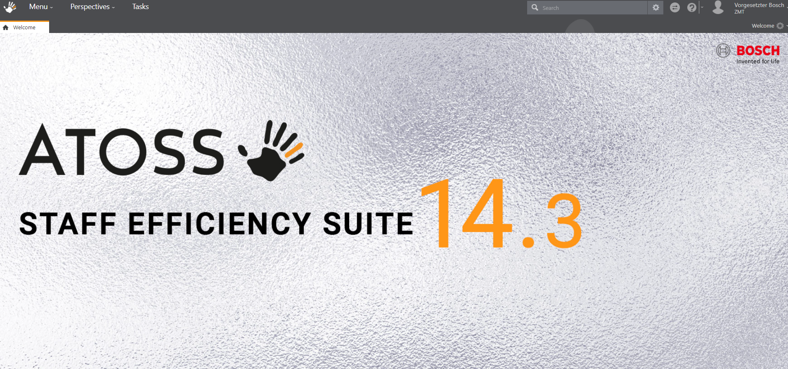

If it does then please click the switch-button on the upper rightern side:

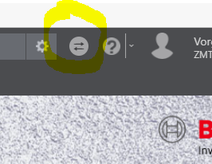

This is what you dashboard will look like:

Quite self explaining☺

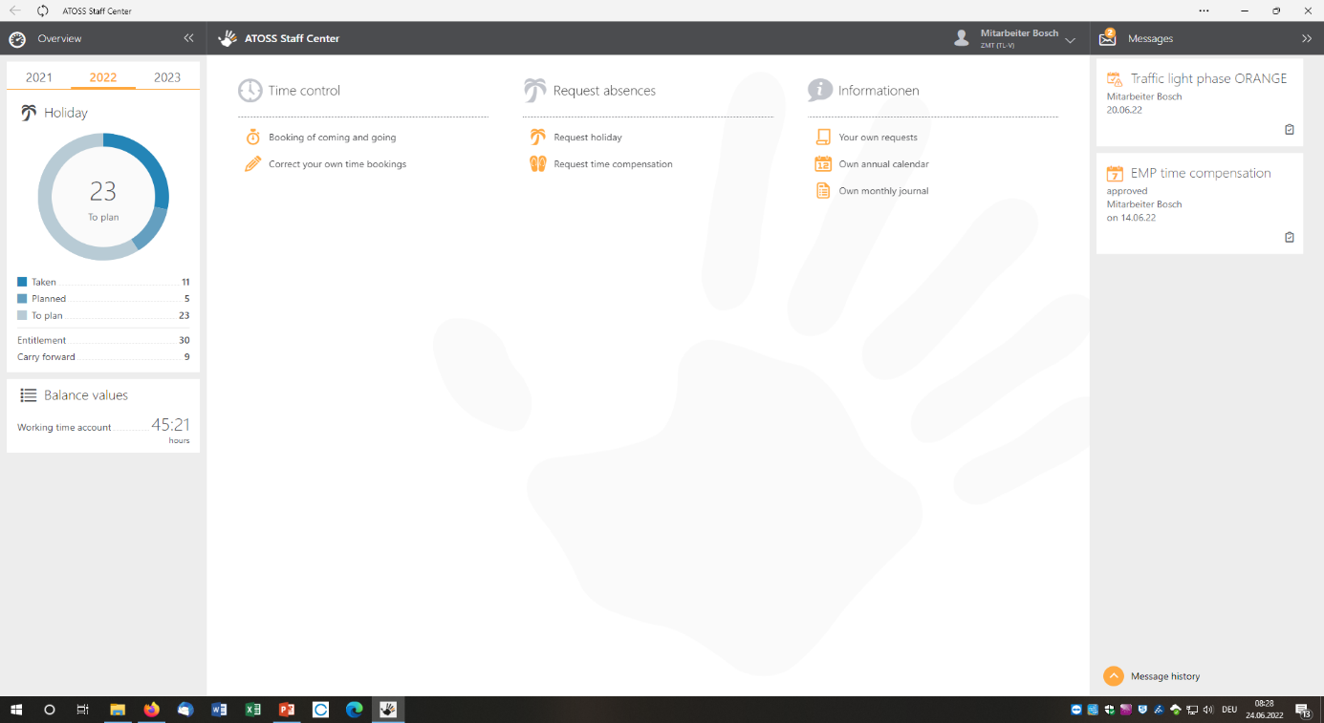

2. Booking of coming and going

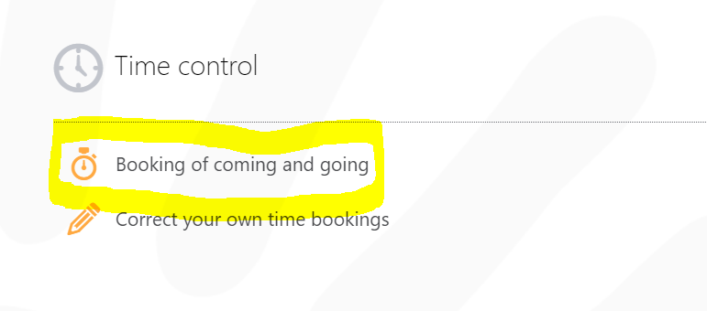

Here you can book your coming and going

or start of break (“Clock start of presence")   
and end of break (“Clock break / end of presence").

This is what it looks like when you have clicked on “Clock start of presence".

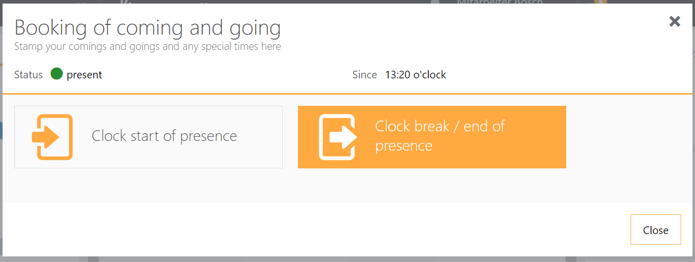

Just pay attention to the color orange.   
It shows you what must be clicked next.

Only if the following notification appears at the lower right side, your booking has been accepted:

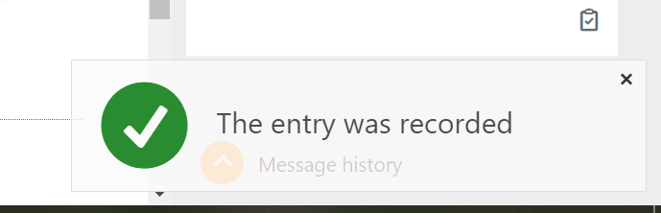

3. Correct your own time bookings

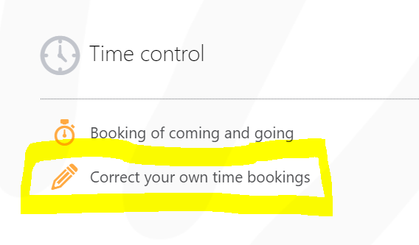

This button allows you to correct a point in time or a period of time.

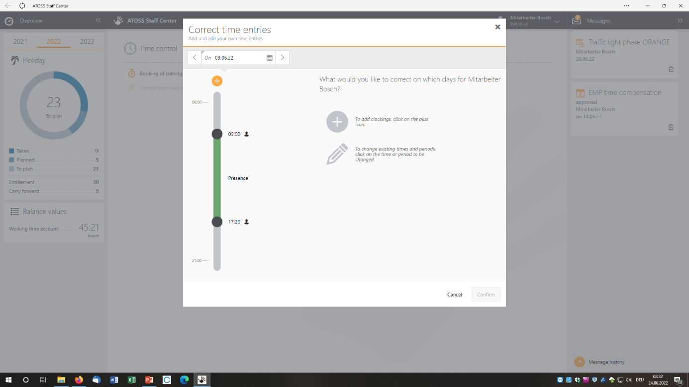

More information how to correct your time bookings are to be found in the document „Bosch-Tips_EN“.

4. Request absences

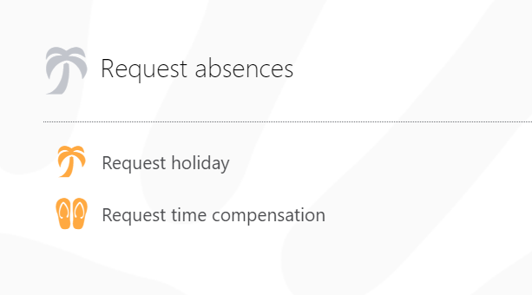

Insert the period of your holidays

Already planned holidays will be displayed like this…

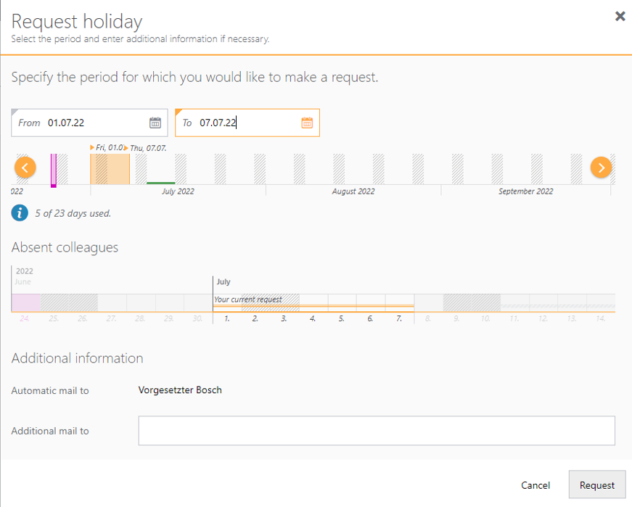

Here you can see how much days will be used or in case of time compensation how much hours will be used.

You´d also get a hint when the planned time period would overlaps with an already planned one.

5. Informations

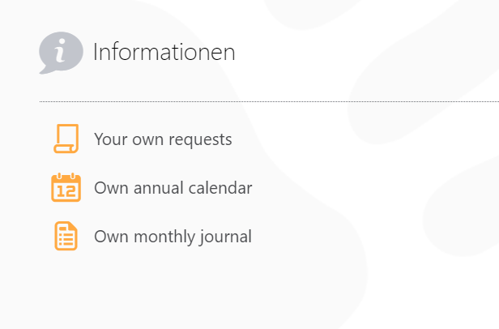

5.1 Overview of your own requests

Your requests can be sorted by status.

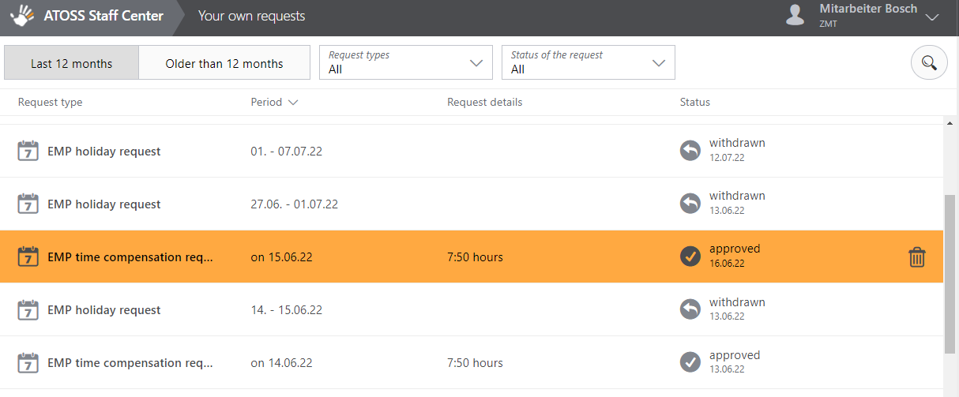

You´ll be able to withdraw your applications. Not yet approved applications will be deleted directly. Already approved ones will need the confirmation of your supervisor.

5.2 annual calendar

Holidays will be displayed in yellow.

Time compensation will be displayed in blue.

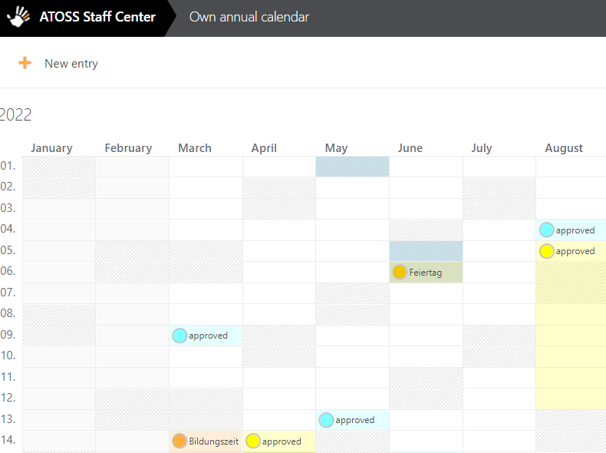

For special leave (e.g. educational leave) please use the conventional/old holiday form.

5.3 monthly journal

You do not have to make any settings for these abbreviations.

Please select the month for which you want to generate a report. For example, if you want to see the bookings for September, enter 01.09.2022 here.

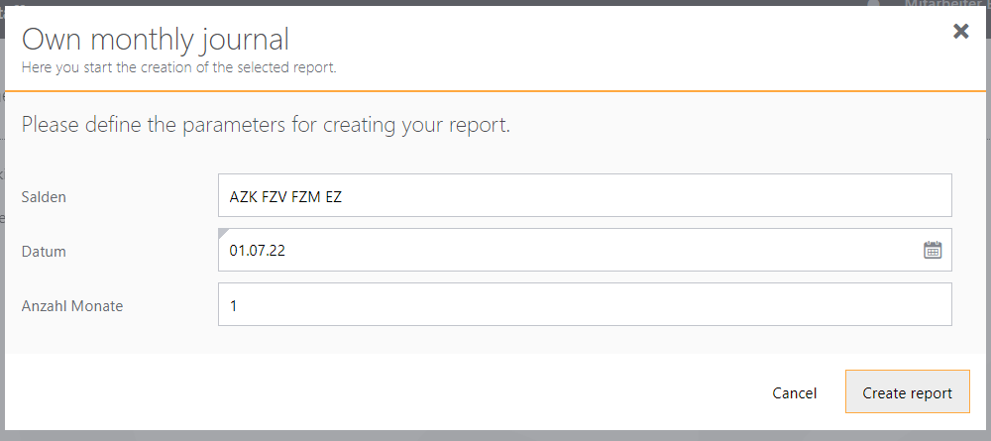

It is also possible to create a report for several months.

Name…

…and department

Not sure exactly how many hours you work for the ZMT per week? Then feel free to check here ;) The figures are decimal.

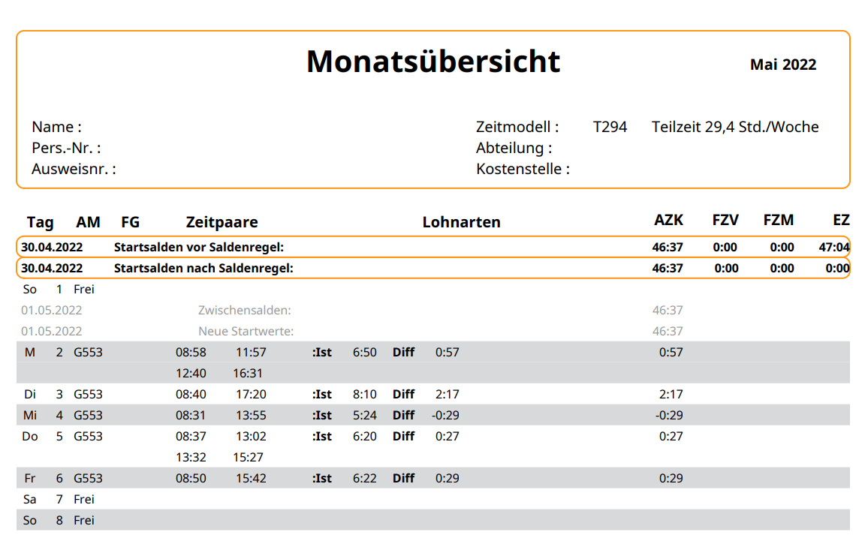

AZK = Working time account

(FZV & FZM only apply for ordered extra work)  
EZ = replacement time

(e.g. in case of sickness)

6. Hints

* Attention: Especially when working from home, you may have to turn off your VPN for Bosch. If it is on, Bosch often does not accept the bookings.

There do not seem to be any problems with the connection via remote.

* Please use the web browser: **Microsoft Edge**.
* Don't worry! Bosch does not measure keyboard speed or hits per minute and continues to run even when the computer is turned off, for example when you change buildings.
* Please make sure to book your working times within the time frame from 6 til 21 o´clock or rather 6 am til 9 pm. Bookings outside this frame as well as bookings on the weekend won´t get counted in Bosch unless there has been a overtime application made by your superior in due time.
* The company agreement on the working time is available at the Alfresco site of the works council: https://intranet.leibniz-zmt.de/share/page/site/work-council/document-details?nodeRef=workspace://SpacesStore/abce7224-d46f-442d-a949-1e0d87a2e12a

7. Advantages Bosch

* Faster approval of your holiday applications
* No more signatures needed
* Better overview of leave and extra work
* No more holiday management in paper 🡪 Saving resources
* Your hours or rather extra work will become visible and you´re able to take days off from it.

To-dos before start:

* Please look up your personnel number on the payroll (or ask at the personnel management) and make a good note of it.
  + Tip: Post-it on your monitor
* For those who already keep timesheets, hand in your last timesheet as soon as possible so that your new balance in Bosch is correct.
* Please request your previously approved leave (from activation date on) in Bosch.
  + Due to the amount of new participants one the one hand the effort for the HR management would be extremely high and on the other hand you would be less able to cancel this leave easily. In addition, you will then practice working with the system.
  + Only the ones who are on holidays at activation date will be entered by us.
  + Holidays taken so far from January - e.g. August 2022 won´t show up in the annual overview. The leave balance in Bosch is the remaining holiday entitlement from the activation date on.

**Any questions, suggestions or other?**

**Then feel free to contact the power users:   
Carina, Lena, Uli & Nele ☺**

**Also feel free to check out a few questions we've already been able to resolve 🡪 FAQs at the Alfresco page of the administration**

Status November 2023

**II. Training for supervisors**

* 1. How to log in 🡪 Switch-Button 15
* 2. Permits 16
  + 2.1 Process requests 17
  + 2.2 Employee annual calendar 20
  + 2.3 Group monthly calendar 21
* 3. Deputies 21
* 4. Expert Interface 24
  + 4.1 Warning list 24
  + 4.2 Monthly journal of the group members 26
  + 4.3Overview of the working time balances 27

**_________________________________________________________________**

1. How to log in 🡪 Switch-Button

Watch out!

After logging in the dashboard will probably look different than expected. Please click the „Switch-Button“ on the upper right:

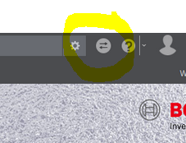

The site will switch to your supervisor dashboard and will look like this:

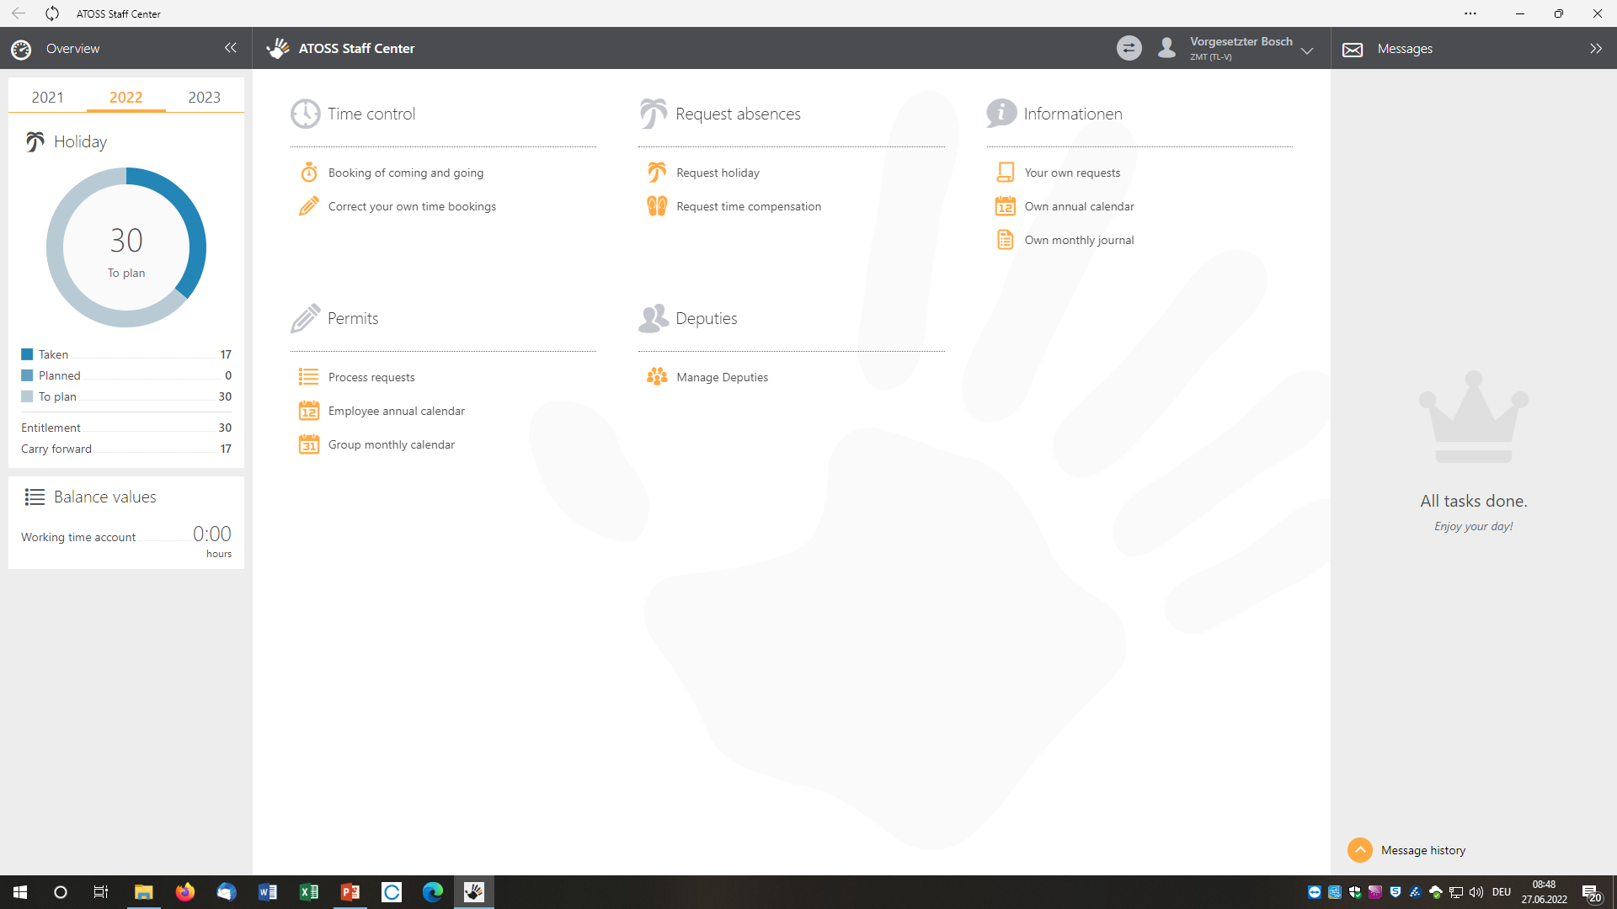



This section is the extension for supervisors.

You´re able to process requests and take a look at your employees annual calendar. You even have an overview of the monthly calendar of your working group. This will help to manage and plan the presence of your working group.

2. Permits

Process requests, take a look at your employees annual calendar or check your group´s monthly calendar.

2.1 Process requests

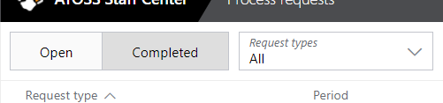

You can filter by open or already completed requests. If all requests are processed the area ‘open’ shall be blank.

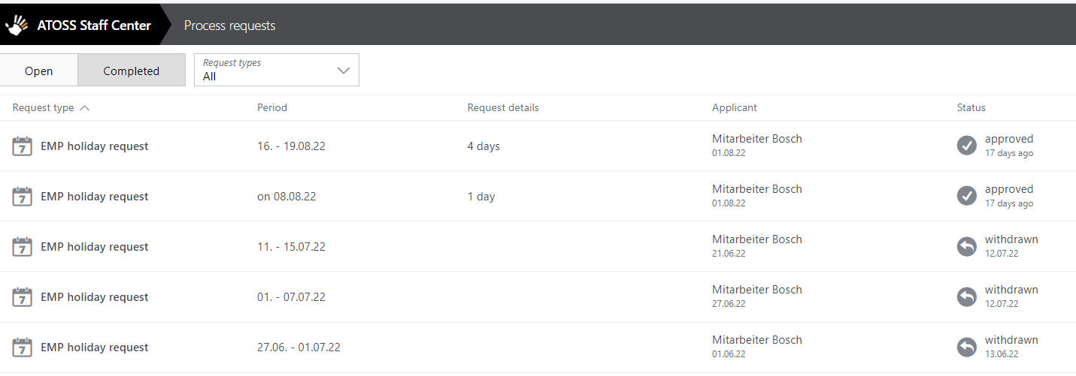

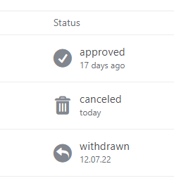

This section shows the status of each request (approved, cancelled, withdrawn)

You can either see new requests in your messages (right side)…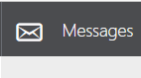

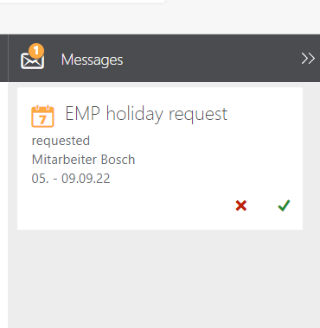

…or choose ‘Process requests’ at the area ‘Permits’…

…and then choose the new or rather open request.

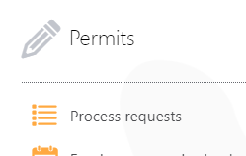

You can insert a comment and even send an additional mail e.g. to colleagues that should be informed about these holidays.

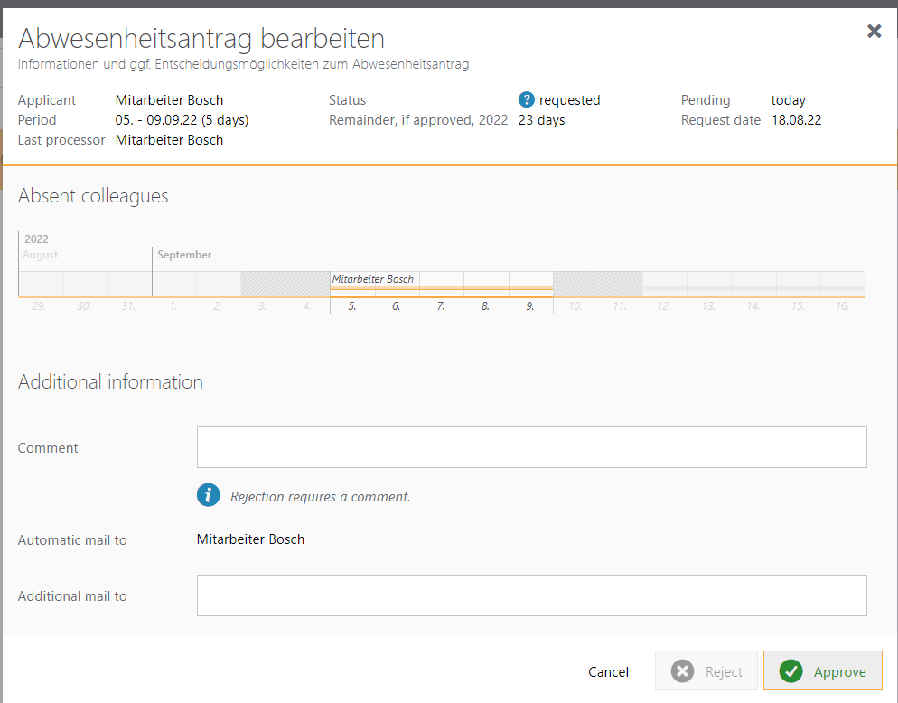

Edit holiday request

Finish ;)

2.2 Employee annual calendar

The Employee annual calendar gives you an overview of the holidays, periods of sickness, time compensation etc. of certain employees.

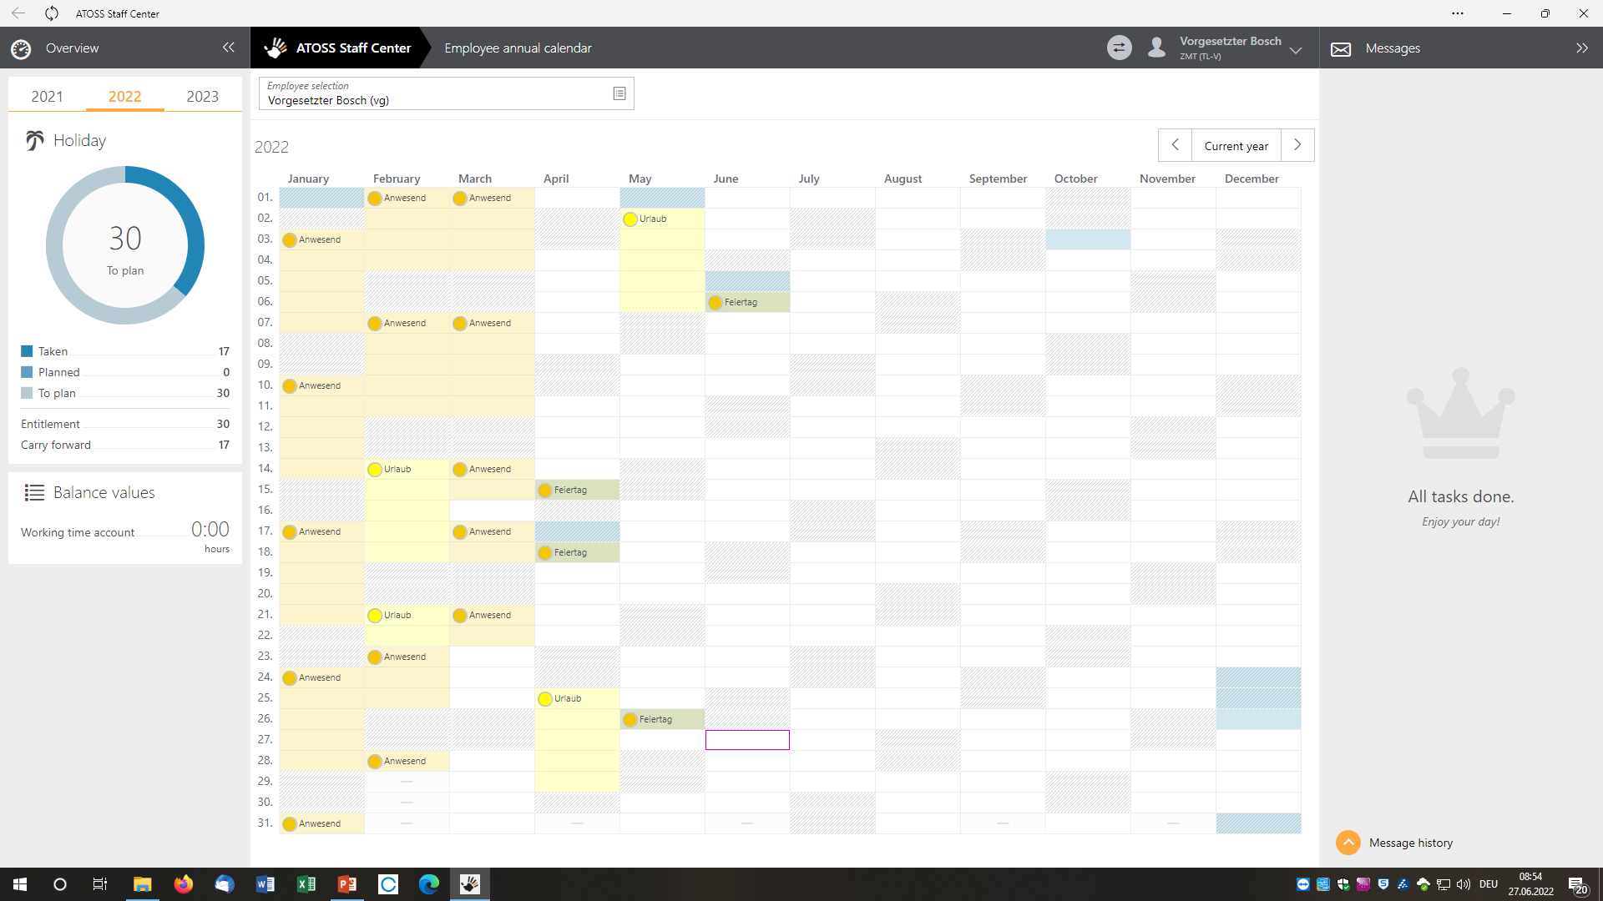

2.3 Group monthly calendar

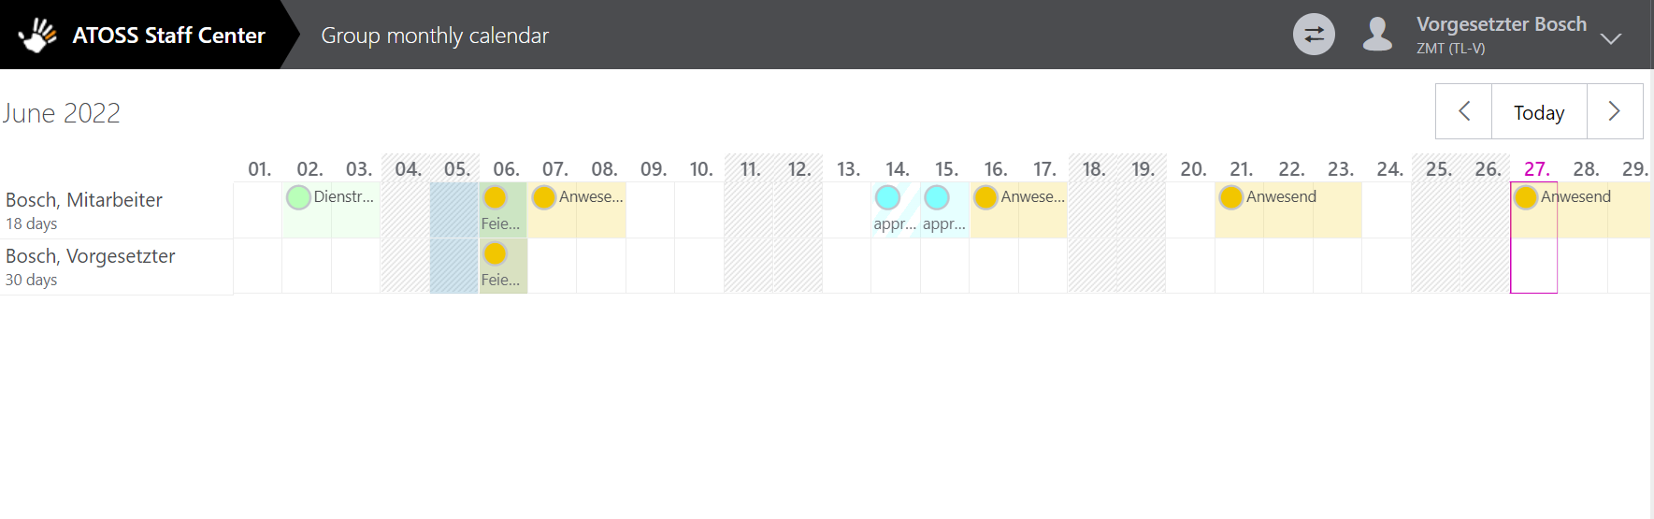

The group monthly calendar gives a good overview of when you´re employees will be around or rather on holidays, time compensation etc.

Switch back- or forward

3. Deputies

Filter by pending or completed deputies…

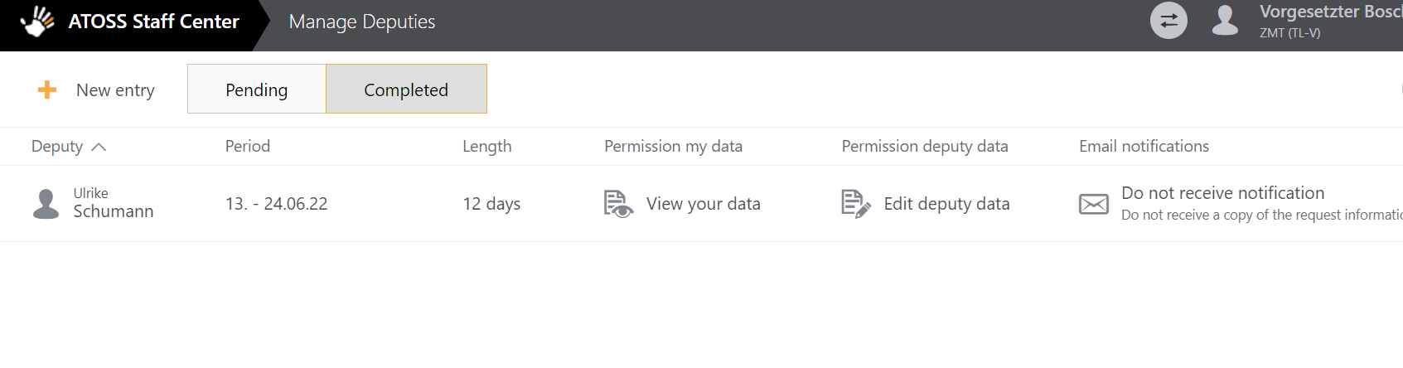



You´re able to set deputies for a certain period but also unlimited.

…or create a new entry:

Determine deputies

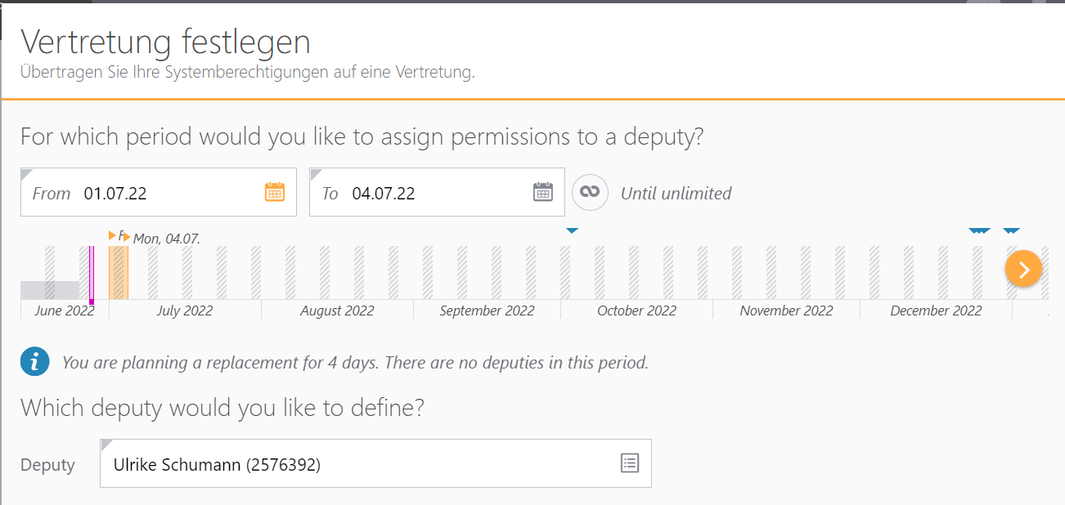

Please choose a deputy preferably on the horizontal level, e.g. a supervisor/work group leader of the same department.

After you´ve set the period and have chosen the deputy the following section will appear. Here you can select wether the deputy shall edit, only view or not use your data (personal data or the data of your group).

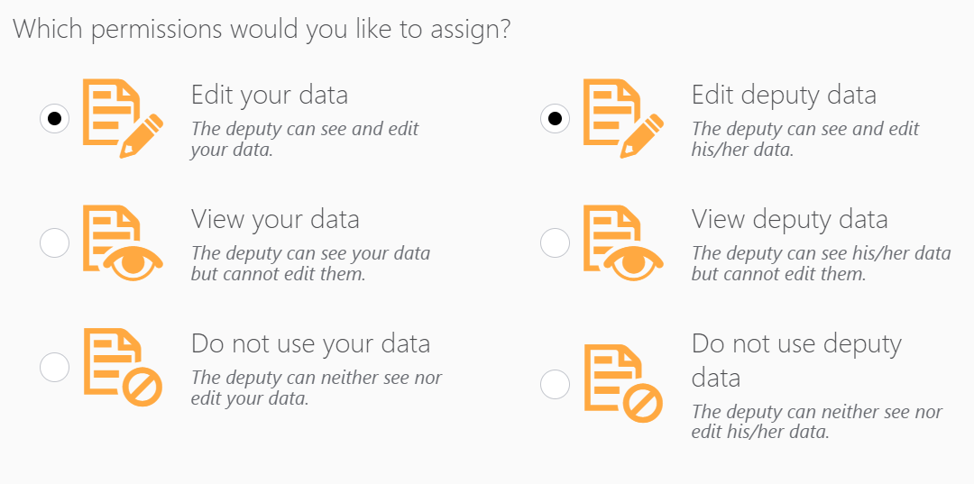

If you still want to receive a mail when there are new requests just thick this box.

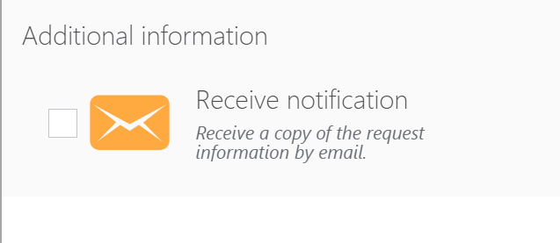

4. Expert Interface

You reach the expert interface by clicking the before mentioned switch-button:



If you click on the menu in the upper leftern corner some fields will appear that will give you a view of the warning list, monthly journals and annual overviews of your employees. 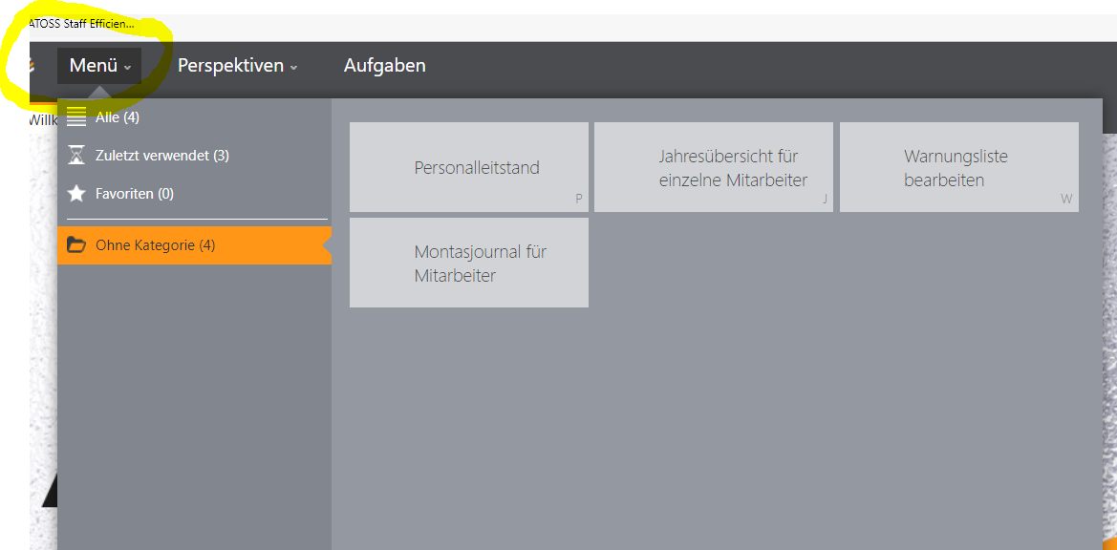

4.1 Warning list

It´s recommendable to regularly check the warning list to ensure that e.g. the maximum working hours (10 hours) are not exceeded or that the resting time (at least 11 hours between the end of the working day and the start of the next working day) is not exceeded, in order to protect the group members.

Open or close the selection

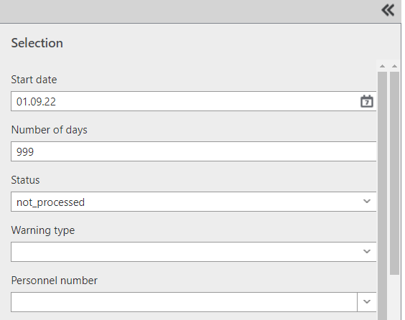

Drop-down function to select

Here you can filter the warning list by various parameters. For example, you can filter the warning type or display only a specific group member (personnel no.).

**🡪 Attention. This is not about controlling the group members but about caring. 🡨**

For more detailed information on how to use the warning list, please contact the power users. ☺

4.2 Monthly journal of the group members

If you select the item 'Monthly journal for employees'(Monatsjournal für Mitarbeiter) in the menu, the following mask will appear:

You don´t need to change this.

Select the group member

You do not have to enter the personnel number, you can also search for names in the drop-down function.

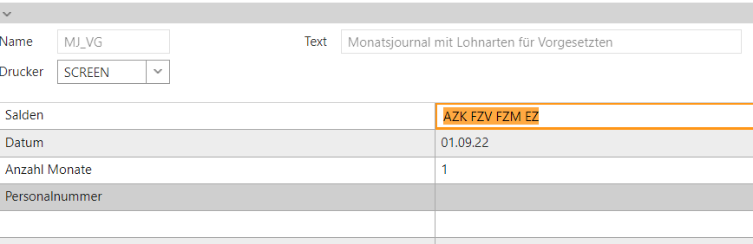

After selecting the parameters press enter or click in the upper leftern corner to create the monthly journal.

The column 'Time pairs' will be empty, no times of coming, going or breaks will be displayed. However, in the column AZK (working time account) you can see whether the respective group member has collected or reduced hours.

**🡪 Here the focus is also on caring. If a supervisor notices e.g. that a group member is collecting more and more hours, a conversation may be necessary to determine together how the group member can be relieved. 🡨**

4.3Overview of the working time balances

Please switch the mode in the Bosch system. To do this, please select the switch button on the top right-hand side:  
 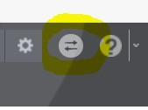

Enter the search command 'sald_exc' (Saldenliste exportieren=export balance list) in the search box (also top right-hand) and press Enter. 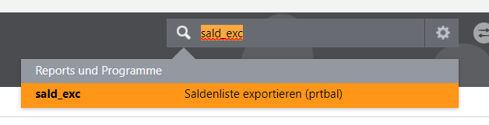

In the line 'Salden (max. 24)' (Salden=balances) you can simply delete the "letter chaos" and insert AZK (working time balance) instead. In the 'Target date' line, the system suggests the last day of the previous month. However, you can also insert the current date. You don´t need to change anything else. Then press Enter or 'Start' at the top left-hand side. Now the system should create the overview.  
The overview appears very large at first, you can simply downsize it by using the minus button in the menu bar. Don't be confused by the "army of zeros" on the right-hand side and only pay attention to the AZK column. Here you can see the value of the working time balance of the respective group members. This value shows how much overtime has been collected.

Status November 2023